Cannon of Death

Guide:

The cannon is the center piece of the angry prims game in SecondLife. This the object by which the user interact with the game. The cannon object uses a sophisticated messaging system developed during the AI modeling game project.

Screenshot:

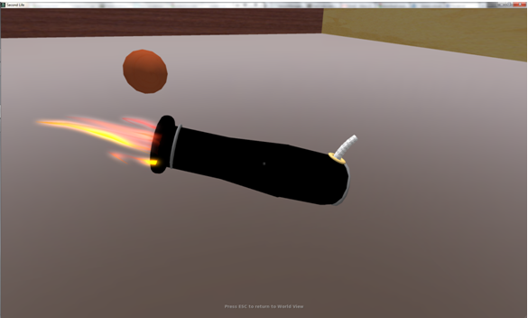

Power:

The cannon is able to send a projectile that follows a parabolic path relative to the projectile's velocity and the force of gravity acting on it. The image below shows the current HUD design.

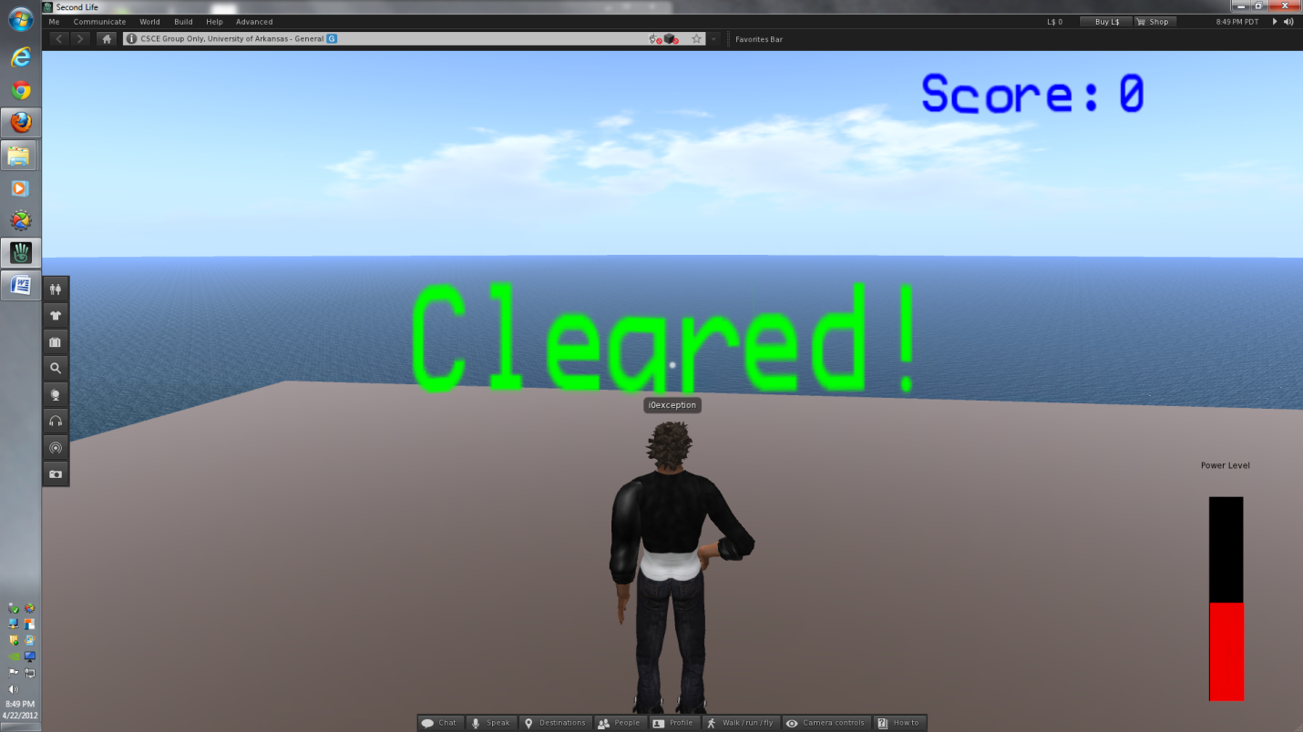

Bullet:

Server Communication:

Commands:

Rotation Manipulation:

Power

Fire: